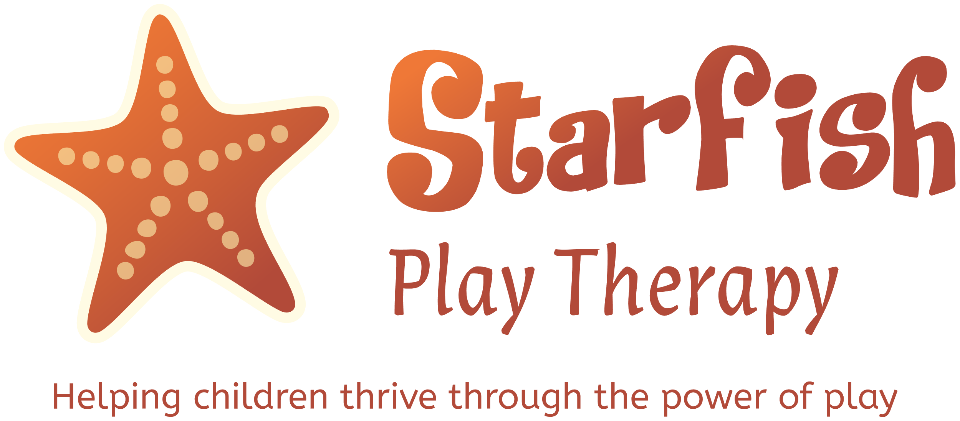

Lisa Mason – Play Therapist BAPT
Website: www.starfishplaytherapy.co.uk
Email: lisa@starfishplaytherapy.co.uk

SAFEGUARDING POLICY
& PRACTICE GUIDANCE

Responsibility (Accountability) | Lisa Mason  Sole Trading as Starfish Play Therapy
Author | Lisa Mason
Effective Date | 1/08/2025
Revision Date | 1/08/2026

Purpose & scope of this policy statement

Starfish Play Therapy provides services to children, young people and families who have social, emotional and behavioural difficulties, and those who have experienced trauma. Children who have had Adverse Childhood Experiences (ACEs) are particularly vulnerable, and this can have a life-long negative effect on their psychosocial, emotional, physical, language, and cognitive development. These experiences could include sexual, physical and emotional abuse; emotional and physical neglect; parental separation, including divorce, imprisonment, and bereavement; substance misuse, mental health issues, and domestic abuse.

This policy ensures that Starfish Play Therapy promotes a positive service culture and has safeguarding as a key principle of care:

- To protect children and young people who receive Starfish Play Therapy services. This includes the children of adults who use Starfish Play Therapy services.
- Starfish Play Therapy provides services to adults, including parents and carers, with the overarching principles that guide Starfish Play Therapy approach to child protection with a clear understanding of the organisation's statutory roles and responsibilities for safeguarding children and young people.
- Starfish Play Therapy understand their responsibility to protect vulnerable adults as well as children and will make referrals if needed to the appropriate avenue.

This policy applies to Lisa Mason, the Sole Trader for Starfish Play Therapy. It sets out how Starfish Play Therapy complies fully with the guidance and legislation on safeguarding, to ensure that those children who access Starfish Play Therapy services, and any other children who may come to the attention of Starfish Play Therapy, receive the protection and support they need if they are at risk of abuse.

Framework

Starfish Play Therapy is committed to promoting the welfare of children and protecting them from the risk of harm.

The Children Act 1989 provides the legislative framework for child protection in England. Key principles established by the Act include:

- the paramount nature of the child's welfare,
- the expectations and requirements around duties of care to children.

Starfish Play Therapy recognises its statutory duty under the Children Act 1989 and Section 11 of the Children Act 2004. Both of these acts are amended by the Childrens social care national framework 2023 which informed Working Together to Safeguard Children 2023. Starfish Play Therapy will cooperate with Local Authorities and work in partnership to safeguard and promote the welfare of children, as defined by this legislation and statutory guidance.

The Safeguarding Vulnerable Groups Act 2006 was passed to help avoid harm, or risk of harm, by preventing people who are deemed unsuitable to work with children and vulnerable adults from gaining access to them through their work.

Serious Crime Act 2015 provides guidance for health and social care professionals, teachers, and the police, including their responsibilities under the female genital mutilation mandatory reporting duty.

Keeping Children Safe in Education 2023 Clarifies the roles of professionals working in schools to safeguard children.

Key Statutory Guidance

Starfish Play Therapy is committed to the key principles and guidance provided through Working Together to Safeguard Children (Department for Education, 2023). This is the key statutory guidance that each organisation needs to follow in order to adhere to its safeguarding responsibilities. This updated version is for anyone working with children in England and sets out how organisations and individuals should work together and how practitioners should conduct the assessment of children. This latest guidance updates the previous version published in 2015. The guidance includes:

- Principles for working with parents and carers – building positive, trusting and cooperative relationships to deliver support to families.
- A focus on referral – highlighting that anyone with a concern about a child's welfare should make a referral to local authority children's social care and sets out an expectation for multi-agency working.
- The Myth Busting guide to information sharing – sets out that sharing information enables practitioners and agencies to identify and provide appropriate services that safeguard and promote the welfare of children:

https://www.gov.uk/government/publications/working-together-to-safeguard-children--2

- A new section on assessment of young carers – setting out the duties of a local authority in carrying out an assessment if a young carer, or the parent of a young career, requests one.

The main changes are:

Principles for working with parents and carers

Importance of building positive relationships to support families

Expectations for multi-agency working

Ensuring agencies and organisations offering a range of roles and activities are involved in supporting families.

New national multi-agency child protection standards

New actions, considerations and behaviours for improved child protection practice

Assessing need and providing help

The guidance highlights specifically that practitioners should, in particular, be alert to the potential need for Early Help for a child who:

- is disabled and has specific additional needs,
- has special educational needs,
- is a young carer,
- is showing signs of being drawn into anti-social or criminal behaviour, including gang involvement and association with organised crime groups,
- is frequently missing/goes missing from care or from home,
- is at risk of modern slavery, trafficking or exploitation,
- is in a family circumstance presenting challenges for the child, such as drug and alcohol misuse, adult mental health issues, and domestic abuse,
- has returned home to their family from care,
- is a privately fostered child.

(See Appendix 1: Safeguarding Children Guidance & Procedures and Appendix 4: Early Help)

Principles

Starfish Play Therapy believes:
- Children and young people should never experience abuse of any kind,
- Starfish Play Therapy has a responsibility to promote the welfare of all children and young people, to keep them safe and to practise in a way that protects them.

Starfish Play Therapy recognises:
- The welfare of the child /young person is paramount,
- All children, regardless of age, disability, gender, racial heritage, religious belief, sexual orientation or identity have a right to equal protection from all types of harm or abuse,
- Some children are additionally vulnerable because of previous experiences, their level of dependency, communication needs or other issues,
- Working in partnership with children, young people, their parents, carers and other agencies is essential in promoting children and young people's welfare.

Starfish Play Therapy seeks to keep children and young people safe by:
- Valuing them, listening to and respecting them,
- Using Starfish Play Therapy safeguarding procedures to share concerns and relevant information with agencies who need to know, involving children, young people, parents, families and carers appropriately,
- Creating and maintaining an anti-bullying environment,
- Ensuring Starfish Play Therapy provides a safe physical environment in accordance with the law and regulatory guidance,
- Recording and storing information professionally and securely.

Responsibilities

Lisa Mason, Starfish Play Therapy, is aware of the responsibility to safeguard and promote the welfare of children, and as such:
- Recognises and responds to concerns about a child or young person in accordance with the Starfish Play Therapy Safeguarding Children policy and procedures.
- Ensures she knows who to contact if there is a concern about a child or young person.
- Knows how to access advice and support from Safeguarding Children's Social Care.
- Accesses safeguarding training and clinical supervision. (Currently DSL trained)
- Writes down what was seen and heard – writes down the place and time – writes down the names of people involved if known.
- Recognises the needs of parents/carers who may need extra help in bringing up their children and knows where to refer for Early Help and to access support as appropriate for them.
- Will follow the Safeguarding Children and Young People Policy and Practice Guidance flow chart.
- Recognises the risks of abuse or neglect to an unborn child.
- Communicates effectively with children and young people and will stay focused on the child's safety and welfare.
- Liaises closely with other agencies, as appropriate, including health, social care and school.
- Is alert to the strong links between domestic abuse, substance misuse, mental health issues and child abuse, and recognises when a child is in need of help, services, or when at potential risk of suffering significant harm.
- Is able, when required, to contribute to Child in Need plans / Team Around the Child (TAC) and strategy discussions.
- Where appropriate, plays an active part, through the Child Protection Plan and Core Groups, in keeping the child safe.
- Is aware how to escalate concerns if not happy with social care response.
- Will monitor and review the application of the policy and procedures.
- Ensures she has appropriate levels of training. (currently DSL trained).
- Ensures there is a clear plan in place on what action needs to be taken.

Supervision

Clinical Supervision is a critical part of maintaining the ethical standards of the British Association of Play Therapists. Lisa Mason complies with this ethical framework as part of her registration process.

https://www.bapt.info/play-therapy/ethical-basis-good-practice-play-therapy/

Approval

Final Version Approved by Lisa Mason Date: 01/08/2026

Lisa Mason: Starfish Play Therapy

Reviewed/revised: 1/08/2026 Next due for annual review 1/08/2027

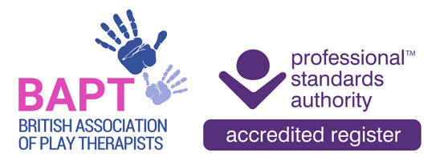
Appendix 1

SAFEGUARDING CHILDREN GUIDANCE & PROCEDURES
(see also Flow Chart in Appendix 2)

1. What does safeguarding children mean?

Safeguarding are the actions that are taken to promote the welfare of children and protect them from harm. Safeguarding means:

- protecting children from abuse, neglect and maltreatment,
- preventing harm to children's health or development,
- ensuring children grow up with the provision of safe and effective care,
- taking action to enable all children and young people to have the best outcomes.

Safeguarding children and child protection guidance and legislation applies to all children up to the age of 18.

2. What is abuse?

The list below is not exhaustive, but illustrates the sort of behaviour that would give rise to a Safeguarding concern:

Physical abuse: is deliberately hurting a child causing injuries such as bruises, broken bones, burns or cuts.

Emotional abuse: is the ongoing emotional maltreatment or emotional neglect of a child. It can seriously damage a child's emotional health and development.

Sexual abuse: a child is sexually abused when they are forced or persuaded to take part in sexual activities. This does not have to be physical contact and can happen online.

Neglect: is the ongoing failure to meet a child's basic needs, the most common form of child abuse.

Other forms of abuse:

Female genital mutilation (FGM): is the partial or total removal of external female genitalia for non-medical reasons.

Online abuse: is any type of abuse that happens on the web, whether through social networks, playing online games or using mobile phones.

Child sexual exploitation: is a type of sexual abuse where someone forces or coerces a child or young person into unwanted sexual activity by using threats, offers of money, drugs or other gifts, or through their power over the victim.

Bullying & cyberbullying: is usually repeated over a long period of time and can hurt a child both physically and emotionally.

Child trafficking and modern slavery: is a type of abuse where children are recruited, moved or transported and then exploited, forced to work or sold.
Domestic Abuse: Witnessing domestic abuse is child abuse The Domestic Abuse Act 2021). Teenagers can suffer domestic abuse in their relationships.

3. Disclosures

Ways that abuse might be brought to the attention of Starfish Play Therapy:

- A child might make a direct disclosure about him or herself
- A child might make a direct disclosure about another child
- A child might offer information that is worrying but not a direct disclosure
- Lisa Mason might be concerned about a child’s appearance or behaviour, or about the behaviour of a parent or carer towards a child
- A parent or carer might make a disclosure about abuse that a child is suffering or at risk of suffering
- A parent might offer information about a child that is worrying but not a direct disclosure

If a child discloses abuse to Lisa Mason, she will:

- reassure the child that telling someone about it was the right thing to do and communicate that she believes them,
- note what the child says and clarify that she has understood correctly,
- tell him/her that she now has to do what she can to keep him/her (or the child who is the subject of the allegation) safe,
- let the child know what she is going to do with the information,
- tell the child how she will feed back to them the outcome of this.

It is not the role of Lisa Mason, Starfish Play Therapy, to question a child, or to investigate allegations, and it is important not to make or infer promises she cannot keep about what may happen as a result of the disclosure.

If the child is in immediate danger Lisa Mason will remain with him/her and call the police.

4. Reporting abuse / concerns

If Lisa Mason suspects or hears an allegation that abuse has taken place or that there is a risk of it taking place, she will decide if it is appropriate for the parent(s)/carer of the child or young person to be informed of the allegation. If the child’s family does not already know of the concern, she will discuss it with them unless:

- a family member might be responsible for abusing the child,
- someone might be put in danger by the family being informed,
- informing the family might interfere with a criminal investigation.

Child Protection referrals will be made to Children's Social Care in line with the relevant Local Authority LSCB Child Protection procedures. The safety of children is paramount in all decisions relating to their welfare. Any action taken should ensure the child is not left in immediate danger.

Child Protection referrals will be completed by telephone in the first instance but then this will be followed up in writing within 24 hours by completing the appropriate Local Authority referral form. A copy of the referral will be retained in the child or adult's records. The outcome of the referral will also be recorded.

Details of statutory Safeguarding Children Processes, including flow charts and time frames can be found in https://www.gov.uk/government/publications/working-together-to-safeguard-children--2

Preventing harm to children from parents with mental health needs
An urgent referral must be made to Children's Social Care if:
- parents/carers/service users express delusional beliefs involving their child and / or
- parents/carers/service users might harm their child as part of a suicide plan.

Preventing harm to non-mobile babies
Non-mobile babies are the most vulnerable. Any concerns or suspicions about maltreatment or observations of bruising in a child who is not independently mobile need to be taken very seriously. NICE guidelines set out that this should lead to an organisation referring the child to Children's Social Care.

Preventing harm to a child or young person at risk of radicalisation
Prevent is part of the Government's counter-terrorist strategy that aims to stop vulnerable people becoming terrorists. It is a multi-agency approach to safeguard people, including children and young people, at risk of radicalisation. Any concerns about a child or young person who may be at risk of radicalisation should be raised with Children's Social Care.

Female Genital Mutilation (FGM)
If Lisa Mason becomes aware of any parent / carer who has had FGM or any female children at risk of FGM this will be discussed with her Clinical Supervisor, in the first instance, unless there is an immediate risk of significant harm to a child.

The Serious Crime Act 2015 places a duty on all health and social care professionals who become aware of FGM in girls under 18 to report it to the Police and to Children's Social Care. This could be if they:

- are informed by a girl under 18 that an act of FGM has been carried out on her,
- or observe physical signs which appear to show that an act of FGM has been carried out.

The report should be made by ringing 101 (or 999 in an emergency). This should be done immediately if there is immediate risk of significant harm or, at the latest, by the close of the next working day.

The following are some indicators that FGM may be planned. Taken in isolation they do not prove FGM will happen, but they are indicators for further investigation:

- Any female child born to a woman who has been subjected to FGM should be considered to be at risk, as must other female children in the extended family.
- Parents from practising communities state they or another family member will take the child out of the country for a prolonged period.
- A child may talk about a long holiday to a country where the practice of FGM is prevalent.
- A child may say that she is to have a 'special procedure' or 'special party'.
- A professional hears reference to FGM in conversation.

Indicators that FGM may already have taken place:

- A prolonged absence from school with noticeable behavioural changes on return.
- A girl having bladder or menstrual problems.
- Soreness, infection or unusual presentation noticed on nappy changing or helping with toileting.
- Recurrent urinary tract infections or complaints of abdominal pain.
- Difficulty walking or sitting or reluctance to participate in sport.

When talking to family Lisa Mason will consider using an interpreter whose values on FGM are known. Family members should not be used as interpreters.

5. Information sharing and consent

Before starting work with a child, Lisa Mason, Starfish Play Therapy, will come to an agreement about confidentiality and will ensure that all parties understand any safeguarding concerns will need to be passed on. This is made explicit in Starfish Play Therapy signed consent forms.

Lisa Mason will seek to discuss any safeguarding concerns with the child's parent(s) / carer(s) unless the discussion might place the child at increased risk of significant harm. Where possible, referrals should be made to Children's Social Care with the parent(s)’s / carer(s)'s agreement. However, where the parent(s) / carer(s) does not agree, Lisa Mason will be clear that a referral will still need to be made. The outcome of the consultation and any further advice will be fully recorded.

A decision by any professional not to seek parent(s)’s / carer(s)'s permission before making a referral to Children's Social Care will be recorded in the child or adult's record and the reasons given.

If Lisa Mason is in doubt about a situation and wants advice before speaking to the family or child / young person, she can contact Children's Social Care and discuss the situation as a 'hypothetical referral', i.e. without mentioning the name of the child.

Lisa Mason has a duty to assist and provide information in support of Child Protection Assessments. Effective sharing of information between professionals and local agencies is essential for effective safeguarding and to promote the welfare of children.

Lisa Mason, Starfish Play Therapy, will follow the Information Sharing Flow Chart in Appendix 5 when making decisions about sharing information relating to a child.

6. Record keeping

Full information about the child(ren) will be recorded at first contact. This will include names, addresses, gender, date of birth, names of persons with parental responsibility, and primary carers. These will be kept up to date and details of every contact should be recorded.

Any safeguarding concerns and actions taken will be clearly documented in the child(ren), adult(s), family's records.

Clear notes will be kept at all stages, including telephone conversations, face-to-face contacts, discussions and supervision discussions.

Record keeping will comply with BAPT’s Professional Codes of Conduct. Lisa Mason, Starfish Play Therapy, is registered with the Information Commissioner’s Office (ICO) as a Data Controller for this sensitive personal information.

Lisa Mason, Starfish Play Therapy, will document when she has discussed specific cases with her Clinical Supervisor and / or other agencies, including Police and Children's Social Care. This should include if there are any specific actions and outcomes as a result of raising a concern.

Any injuries should be documented using the Safeguarding Body Map (Appendix 6).

7. Using an interpreter

Family members, including children and young people, friends or partner will never be used as an interpreter in a situation where there are child safeguarding concerns as this could increase the risk to the child. If interpreting services are required, these will be arranged.

8. Allegations against starfish play therapy

Any allegation against Lisa Mason, Starfish Play Therapy, having behaved in an inappropriate way will be reported to the Local Authority Designated Officer (LADO). Any allegation of abuse will be referred immediately to the appropriate Local Authority.

Lisa Mason will also inform her Clinical Supervisor and the British Association of Play Therapists (BAPT).

9. Escalation process

If Lisa Mason believes a decision made by a practitioner in another agency is not safe in relation to Child Protection or a Child in Need, she will challenge decisions made and will follow Local Authority Escalation Policies.

10. Incident reporting, Local Child Safeguarding Practice Reviews (lcspr), and Serious Incidents Requiring Investigation (siri),

All LCSPRs involving Lisa Mason’s services will be undertaken in line with the LSCB Serious Case Review Protocol. Starfish Play Therapy and LSCB recommendations and action plans from LCSPR’s will be incorporated into Starfish Play Therapy policies and procedures to improve and develop practice.

Appendix 2
STARFISH PLAY THERAPY
SAFEGUARDING CHILDREN'S REFERRAL FLOW CHART

If there is immediate risk of serious harm, contact the Local Authority, Children's Social Care immediately and / or dial 999 and ask for the Police.

Lisa Mason has a
safeguarding concern

After careful consideration, possibly having discussed 'hypothetically' the concern with Children's Social Care, if a Safeguarding concern continues?

NO
YES

Agree what other support is needed, e.g. to another service and / or Early Help Assessment.

Discuss with parent(s) / carer(s) and agree a plan.
Lisa Mason contacts parent(s) / carer(s) if appropriate. Discusses concerns with them and informs them of the need to refer to Children's Social Care

If decision is made that contacting the parent(s) / carer(s) is not appropriate, rationale must be clearly documented.

Lisa Mason contacts Children's Social Care and follows up verbal referral in writing within 24hrs.
Document discussions and outcomes on child, adult, and family's record.

LA Duty Social Worker should acknowledge referral and decide on course of action within one working day. If this does not happen, contact them to find out what action has been taken.

Copy of referral should be saved in child, adult, and family's record.
Appendix 3

CONTACT DETAILS FOR LOCAL AUTHORITY CHILDREN'S SOCIAL CARE
DAYTIME AND OUT OF HOURS SERVICES

Bath & North East Somerset Council:
Children & Families Assessment and Intervention Team: 01225 396312 or 01225 396313
Out of Hours Emergency Duty Service: 01454 615165
https://www.bathnes.gov.uk/services/children-young-people-and-families/child-protection

Somerset Council:
Somerset safeguarding children partnership: Somerset Safeguarding Children Partnership
Children’s Social care: 0300 123 2224
Frontdoor: 0300 123 3078
Email: childrens@somerset.gov.uk

Dorset Council:
Children's Advice and Duty Service (ChAD) for professionals (Single point of contact for professionals for safeguarding concerns): 01305 228558
https://www.dorsetcouncil.gov.uk/children-families/worried-about-a-child.aspx
North Dorset locality Email: northlocality@dorsetcouncil.gov.uk Tel: 01258 474036

Wiltshire Council:
Multi-Agency Safeguarding Hub (MASH): 0300 456 0108 (8.45am-5pm [Mon-Thurs] and 08.45-4pm [Friday])
Out of Hours Emergency Duty Service: 0300 456 0100
https://www.wiltshire.gov.uk/children-young-people-protection
Wiltshire Safeguarding Children’s Board: https://www.wiltshirescb.org.uk/children-and-young-people/

NOTE: Contact will be made to the relevant LA who is responsible for the child or young person.

Appendix 4
EARLY HELP

Early Help – formally known as Common Assessment Framework (CAF) is a way of identifying needs at the earliest stage for children and young people. It involves listening to children and young people (and their parents / carers) to find out what their needs may be and what is working well. It can help to identify any extra help that might be needed. It will then help children and young people receive the right support at an early stage before their needs increase. Early Help relies on the principle of all professionals involved communicating with young people, children, and families, and with each other, to provide the best integrated package of support.

Early Help will ensure that everyone involved with children and young people, such as teachers or health visitors, work together to support children and young people. An action plan is then put together to make sure that the right sort of help is provided.

In delivering services to meet the needs identified for a child or young person, where more than one agency is involved, one of the practitioners takes a lead role. This practitioner is called the Lead Professional. This will ensure that meetings of all the practitioners working with a child, young person or family take place, and services are delivered that are joined up and achieve intended outcomes. These arrangements are known as Team Around the Child (TAC) and the Lead Professional is key to this achieving better outcomes for children and young persons. Team Around the Family may also be used where whole family solutions are needed.

The Lead Professional is not responsible for delivering all of the services needed by the child or young person, but takes on a coordinating role and acts as a single point of contact for the child, young person, and family. Each member of the Team Around the Child / Family network plays a part in supporting the child, young person, family, and Lead Professional in achieving the outcomes in the plan.

Starfish Play Therapy will actively participate in Early Help by making referrals, being part of the network supporting a child and / or family through the arrangements known as Team Around the Child / Family. However, in order to protect the therapeutic relationship between child / young person and therapist, e.g. Lisa Mason will not take the role of Lead Professional.

Appendix 5

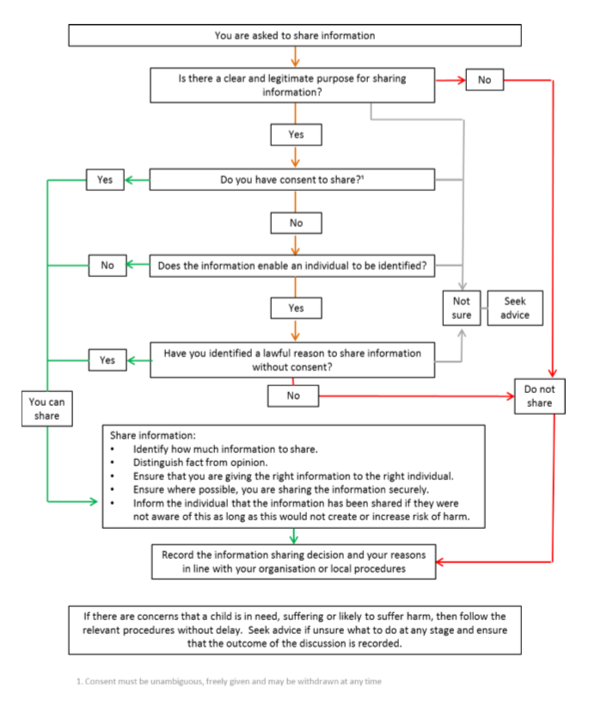
FLOW CHART OF WHEN AND HOW TO SHARE INFORMATION
Appendix 6

BODY MAP FOR SAFEGUARDING PROCEDURES

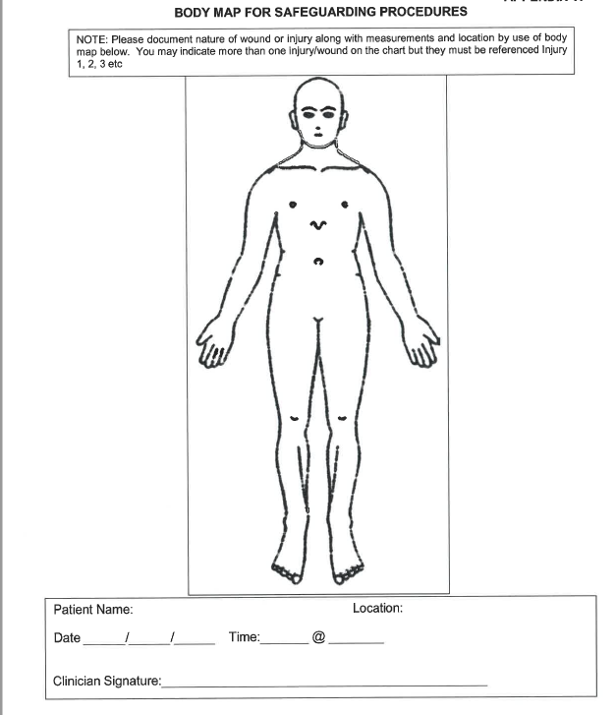
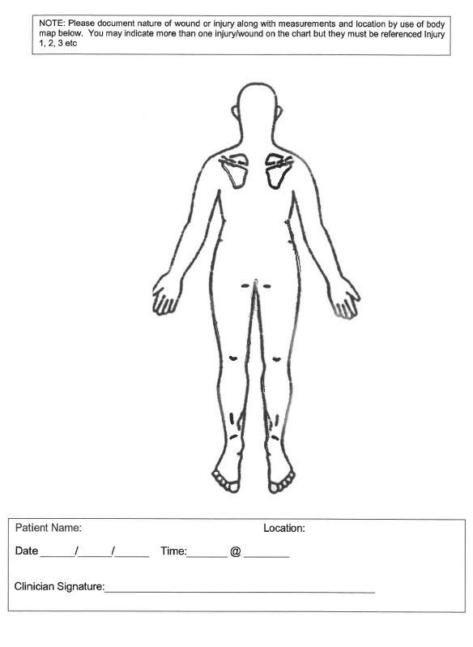

Safeguarding children and young people
E-safety policy and agreement

1. Background

The use of information technology is an intrinsic part of the experience of children and young people, and can be greatly beneficial to them. However, it can present challenges in terms of how we use it responsibly and, if misused either by an adult or a young person, can be actually or potentially harmful to them and others.

In the day-to-day face to face work of Starfish Play Therapy, technological equipment will be limited to Lisa Mason taking photos of children and young people's creative work eg. sand play trays. Mobile phones and devices are not allowed to be used during therapeutic sessions, one-to-one contact, and / or family meetings unless it is therapeutically deemed appropriate. In the event that the usage of a mobile phone / device is deemed to be therapeutically appropriate the following principles and guidance should be carefully considered and followed:

2. Principles

- The welfare of children and young people who come into contact with Starfish Play Therapy is paramount and should govern Starfish Play Therapy approach to the use and management of electronic communications technologies and online behaviour.
- All children, regardless of age, disability, gender, racial heritage, religious belief, sexual orientation or identity, have the right to equal protection from all types of harm or abuse.
- Working in partnerships with children, young people, their parents, carers and other agencies is essential in promoting young people's welfare and in helping young people to be responsible in their approach to e-safety.

3. Purpose of the e-Safety Policy

- To help protect children and young people who receive Starfish Play Therapy services and who make use of information technology (such as mobile phones / devices and the internet) as part of their involvement with Starfish Play Therapy – whether the equipment is provided by Starfish Play Therapy or is their own.
- To ensure as an organisation Starfish Play Therapy operates in line with its values and within the law in terms of how information technology is used by children and young people.

4. How Starfish Play Therapy will seek to keep children and young people safe
Lisa Mason will be responsible for dealing with e-Safety issues that arise in relationship to children and young people.

Starfish Play Therapy will:

- ensure there is adequate physical security for Starfish Play Therapy information and communication technology (ICT) equipment,
- ensure the effective management of ICT issues,
- examine and risk assess any emerging new technologies before they are used within the organisation,
- support and encourage children and young people using Peartrees and Bees services to use the opportunities offered by mobile phone technology and the internet in a way that keeps themselves safe and shows respect for others,
- support parents / carers to do what they can to keep their children safe online and when using their mobile phones / devices, including signposting them to resources such as NSPCC and the Safe Internet Centre:
ww.nspcc.org.uk/preventing-abuse/keeping-children-safe/online-safety/
www.safeinternet.org.uk/
- ensure user names, logins and passwords for Starfish Play Therapy ICT equipment are used safely,
- ensure that personal information of children and young people is not published on Starfish Play Therapy website or on any social media,
- ensure no images of children, young people and their families will be used to publicise the work of Starfish Play Therapy.
- follow the relevant local authority guidance for e-safety.

THIS POLICY WILL BE UPDATED ANNUALLY (updated August 2026)

